Program Information | [Lesson Title]  Mathin’ Around the House |  |  |  |  | TEACHER NAME |  |  | PROGRAM NAME
Program Information | [Unit Title] |  |  |  |  | NRS EFL(s)  2 – 4 |  |  | TIME FRAME  240 – 480 minutes (double lesson)
Instruction | ABE/ASE Standards – Mathematics
Instruction | Numbers (N) |  |  | Algebra (A) |  | Geometry (G) |  |  | Data (D)
Instruction | Numbers and Operation |  |  | Operations and Algebraic Thinking |  | Geometric Shapes and Figures |  | G.2.1, G.2.3, G.3.1, G.3.2, G.3.5, G.4.2, G.4.4 | Measurement and Data
Instruction | The Number System |  |  | Expressions and Equations |  | Congruence |  | G.4.5 | Statistics and Probability
Instruction | Ratios and Proportional Relationships |  |  | Functions |  | Similarity, Right Triangles. And Trigonometry |  |  | Benchmarks identified in RED are priority benchmarks. To view a complete list of priority benchmarks and related Ohio Aspire lesson plans, please see the Curriculum Alignments located on the Teacher Resource Center (TRC).
Instruction | Number and Quantity |  |  |  |  | Geometric Measurement and Dimensions
Instruction |  |  |  |  |  | Modeling with Geometry
Instruction | Mathematical Practices (MP)
Instruction | ☑ | Make sense of problems and persevere in solving them. (MP.1) |  |  |  | □ | Use appropriate tools strategically. (MP51)
Instruction | ☑ | Reason abstractly and quantitatively. (MP.2) |  |  |  | □ | Attend to precision. (MP.6)
Instruction | ☑ | Construct viable arguments and critique the reasoning of others. (MP.3) |  |  |  | □ | Look for and make use of structure. (MP.7)
Instruction | ☑ | Model with mathematics. (MP.4) |  |  |  | □ | Look for and express regularity in repeated reasoning. (MP.8)
Instruction | LEARNER OUTCOME(S)  Students will be able to apply formulas and theorems about shapes, angles, parallel lines, and perpendicular lines. |  |  |  |  | ASSESSMENT TOOLS/METHODS  Each of the “you do” steps will serve as assessment. The instructor should be able to gauge understanding by having different students provide their solutions and explanations of how they arrived at that solution. In addition, during the “we do” steps, instructors should be encouraging all students to participate in the discussion. The ability to provide input in these discussions will help the teacher gauge each student’s mastery of the concepts.  Students can turn in one part of the Tessellating Tiles handout. In addition, for the second part of the lesson, they can pick different lines in the room that seem parallel and test to see if they actually are. A chalk tray to the top of the board. Lines on the floor. Lines on paper. Table edges. They can then draw the scenario as well as their measurements to show whether or not the lines they picked were parallel and why.
Instruction | LEARNER PRIOR KNOWLEDGE
Instruction | INSTRUCTIONAL ACTIVITIES  Note: Keep in mind that your class may not need to go through each of the parts below. Please pick and choose which elements to incorporate into your actual lesson based on what you know of your students. In addition, extra sample problems may need to be incorporated based upon your particular class.  Part 1: Geometry is a branch of mathematics that relies heavily on definitions. As such, we need to build these definitions for our students. Ask students to define the terms point, line, and plane. Encourage them to give examples to help explain the three concepts. If they try to define one of the words using another geometric term, have them define the new word. Eventually, the discussion should come to a standstill where the students cannot define these three terms. It should also have been shown that many definitions in geometry rely on other terms. Now, let’s give them a starting point.  Define the three terms as follows:  Point – describes the precise location of something but has no position, length, or width itself (Examples: room corners, pencil tips)  Line – an indefinite length which has no depth or thickness. A line passing through points A and B would be notated as: . (Note: A line can also be thought of as an infinite collection of points) (Examples: edges of objects if they were to extend forever)  Plane – a flat surface (Examples: table tops, walls, if they were to extend forever)  We now want to build upon these three terms to define rays, line segments, and angles. Open up a discussion with the students about each term, asking for examples, and trying to build definitions. We want to aim for something similar to the following:  Ray – portion of a line. Starts at a point (endpoint) and extends indefinitely in one direction. A ray passing through points A and B, with A as the endpoint would be notated as: . If the endpoint was B, the arrow would point in the other direction.  Line segment (sometimes just segment) – portion of a line that has two endpoints. A segment with endpoints A and B would be notated as: .  Angle – the space created when two rays (or lines, or segments) intersect.  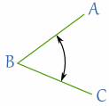  The above angle would be notated as: . The point that represents the vertex of the angle should always be the middle letter.  The last concepts we want to work with at this level allow us to talk about spatial relationships. The first two terms are vertical and horizontal. Once again using discussion with the class, have the students compare and contrast the two terms. If they would like, have a student give a visual representation of each term. Since we have defined lines and segments, they could draw a vertical segment and a horizontal segment to help define the terms. We should come to a consensus that vertical means extending straight up and straight down, while horizontal means extending left to right. We should note that these definitions really only apply to lines, segments, and rays as planes extend in all directions and angles are formed by two intersecting lines. (Vertical angles will come up later.) The final term is adjacent. This time, we are thinking about adjacent angles and adjacent sides of an object. After discussion, we want to reach the idea that adjacent basically means “next to”. In fact, adjacent objects share something. Adjacent angles share a common side and adjacent sides share a common vertex.  Part 2: Angles are an important part of geometry. They factor heavily in the upper level standards, especially for trigonometry and rotations. While we name angles based upon the lines (rays or segments) that form them, we classify them based on their size, or the amount of degrees in the angle. While there are technically six classifications for angles, three are much more common than the others. The six classifications are:  Acute – angles with degree measures between 0° and 90°  Right – angles with degree measures of exactly 90°  Obtuse – angles with degree measures between 90° and 180°  Straight – angles with degree measures of exactly 180°  Reflex – angles with degree measures greater than 180°  Full rotation – angles with degree measures of exactly 360°  The first three are the most commonly used classifications. For angles greater than 180°, the measurement is often taken so that the protractor takes the smaller measurement. For example, a reflex angle measuring 230° could also be measured to have an angle of 130°.  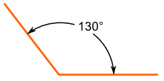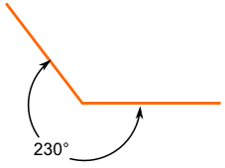  Using the compasses and dry erase kits, the students will now learn how to measure/classify angles. We will do this using explicit instruction.  (I do) Start by drawing yourself an angle, making sure to label it properly. Go over the fact that the angle can be measured in two different ways, as shown by the pictures above. Most protractors, including the ones in the kit, only measure up to 180°. This means you will always have to measure the smallest distance for the angle, or the 130° in the above picture. (However, the reflex angle can always be found by subtracting the angle measurement from 360°.) Make sure to show students how to line up the right edge, or 0° mark, with the right side of the angle. Then, they want to look for the closes degree mark that the other side passes through on the protractor. Based on the angle you drew, make sure to give the students the appropriate classification for it.  (We do) Using the gridlines on the back of the graph board, have each student draw a vertical line and a horizontal line that intersects the vertical line. Do the same at the front of the class. This ensures that everyone should have the same angle to work with. Have the students walk you through how to measure the formed angle. Within a small margin of error, everyone should have an angle that is 90°, a right angle.  (You do) Now have the students create their own angles, or in pairs have them create angles for each other. Then have them measure/classify each angle. During this time you should be walking around, correcting any incorrect usage of the protractors and giving feedback. (For further exploration, they could also measure angles around the room. A desk corner, angles formed between fingers, angles on pictures around the room.)  The final part of classifying angles would be to note complementary and supplementary angles.  Complementary angles – two angles whose measures sum to 90°.  Supplementary angles – two angles whose measures sum to 180°. These do not have to be adjacent (thus making a straight angle).  (Note: One way that I find easy to remember the difference between complementary and supplementary angles is the fact that 90 comes before 180 and, alphabetically, complementary comes before supplementary. So complementary goes with 90° and supplementary goes with 180°. While this works for me personally, it may not work for everyone.)  Once the definitions are given, go over how to find each of the new angle types.  (I do) Start by drawing yourself an acute angle, making sure to label it properly. Using your protractor, find the measure of the angle. Now find the complement of this angle. This should mean setting up the equation where is the measure of your angle and is the measure of the complement to your angle. For the supplement, the equation would be where is the measure of your angle and is the measure of the supplement to your angle.  (We do) So that each student is working with the same angle, have everyone make a 45° angle using their protractors. Since they created an angle of a certain measure, our first step from the “I do” process is done. Now we just need to find the complement and supplement. Have them guide you on how to find the complement. This should lead to you setting up and solving the equation , and finding that . For the supplement, you should instead be setting up and solving the equation , and thus .  (You do) Now have the students create their own angles, or in pairs have them create angles for each other. Then have them measure each angle and find its complement and supplement. During this time you should be walking around, correcting any incorrect usage of the protractors and giving feedback. (For further exploration, students could challenge one another. “Draw the complement to an angle of measure 30°.”)  Using the Pocket Attribute Block kits, make sure every student (pair or small group) has at least one of every shape. As a class, see if you can name every shape in the kit (square, rectangle, triangle, circle, and hexagon). From there, we want to be able to describe the attributes of the different shapes. We will use explicit instruction:  (I do) Start with the square. It may be helpful to draw one up front so that everyone can see it and you can notate the different parts. There are different parts of the shape we can describe: number of sides (edges), number of corners (vertices), whether there are perpendicular/parallel sides, the measures of the angles, and whether any of the sides are the same length (congruent). Carefully explain any vocabulary words the students do not already know.  Vertex – The point where two or more lines meet.  Edge – The line segment joining two vertices.  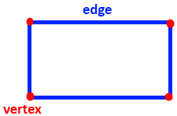  Congruent – Having the same size and shape. For line segments, this means two segments have the same length. For angles, this means two angles have the same degree measure. For shapes, this means corresponding sides and angles are congruent.  After getting the definitions down, you can start listing the attributes of a square and marking them on your picture.  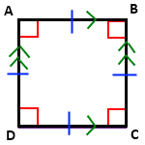  4 vertices and 4 edges  4 right angles (marked by red squares and created by perpendicular, adjacent sides)  4 congruent sides (marked by blue dashes)  Opposite sides are parallel (marked by green arrows, parallel sides have the same number of arrows)  This would be a good time to show them how to write geometric statements as well. (Ex. , and .)  (We do) As a group discussion, have the class walk you through the attributes of the triangle. (Note: The triangle should be done as a group as opposed to alone since the one in the kit is an equilateral triangle. This way you can let them know there are triangles that do not have 3 congruent sides and angles.)  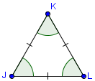  3 vertices and 3 edges  3 congruent angles (not necessarily always the case)  3 congruent sides (not necessarily always the case)  It is probably a good idea to do the circle as well, since there is some vocabulary involved that they may not be familiar with. They will need the following definitions:  Radius – distance from the center of the circle to any point on the circle (Note: The “circle” is the outer edge, not the space in the interior.)  Diameter – the distance across a circle, going through the center point of the circle  For their attributes they should have:  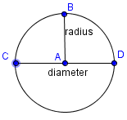  No vertices or edges  360° in the interior  The diameter is twice the radius  (You do) In small groups, pairs, or alone, have them do the other two shapes. They should come up with a list of attributes, as well as draw and notate the congruencies and parallel/perpendicular lines. During this time you should walk around, offering feedback and correcting any mistakes. This also lets you assess their learning.  Following this last section, you can discuss what shapes can be classified as more than one thing. (A square is a rectangle.) This might also be a time to touch back on how there are many types of triangles, not just the equilateral one.  Still with the two-dimensional shapes, we will now find perimeter and area of different shapes. The hexagons will not be needed during this part, but the other four shapes can be used. The following two definitions will be necessary:  Perimeter – distance around a two-dimensional shape, for circles this is called the circumference  Area – the amount of space contained within the edges (or boundary for a circle) of a two-dimensional shape  (I do) Start with the square again. It may be helpful to draw one up front so that everyone can see it and you can notate the measurements. Using the ruler portion of the protractors, measure the length of one side of the square (either the big square in the attribute blocks kit or the small one). Mark that measurement on the picture, making sure to include proper units. Based on the attributes listed for a square, all sides are the same length. This means you can fill in the other three sides without having to measure them. Now, since perimeter is just the distance around the shape, all we must do is add the length of all of the edges. Our units will not be squared or cubed here since our measurement only takes into consideration one dimension. A formula is unnecessary here. For area, we know that a square is a rectangle, so we can use the more general formula for area of a rectangle: . The units this time will be squared since the space we are measuring covers two dimensions.  (We do) As a group discussion, have the class walk you through finding the circumference and area of a circle. (Note: It may be helpful to give them the formulas first. and ) It may take a bit of guess work to try to estimate where the center of the circle is so that the radius can be measured. Once the radius is agreed upon (it will be different for the big circle vs. the small circle, so the problem can be done twice), plug that value into the formulas to find the perimeter and area. The units work the same way as for the square, to the first power for perimeter and squared for area. You may have to help them with the idea of . It is often best to leave the answers in terms of , unless rounding has been discussed and calculators are available.  (You do) In small groups, pairs, or alone, have them do the other two shapes. For triangles, the area formula is , where b=length of the base, and h=the height (length of the segment from the vertex opposite the base perpendicular to the base). In the image below, is the base and is the height.  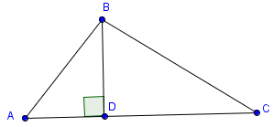  Part 2: Now that students have some background knowledge on shapes, let’s consider a family, the Johnson family, that wants to remodel/redesign their home. They choose to focus on redoing the living room, bathroom, and kitchen. In the kitchen and bathroom, they decide to go with tile patterns that are more than just the normal checkerboard patterns.  For example:  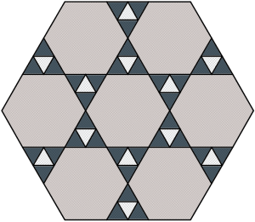  (I do) Let’s consider the above pattern. It is also on the Tessellating Tiles Exploration handout, so make sure each student has one of those. It may also be a good time to hand out the compass/protractors/rulers at this time as they will be using them for this part of the lesson. The Johnsons want the above pattern to be in their shower. Go over the sample questions, as well as any others you can come up with, that are listed on the handout. Also, fill out the sample chart for the problem as well.  Taking the shape on the paper, we want to explore the interior shapes that make up the entire pattern. We want to name them, find out about them, find out about their side lengths and angle measures, and decide if there are any similar or congruent shapes. We will use the ruler/compass/protractor (Slide N’ Measure) to find out more about the sides and angles. Then, we will use the definitions of similar and congruent to figure out if we have any of those types of shapes. Finally, we will use some properties of angles to help us out as well. First, let’s notice that we have three different colors in the pattern. It appears that each color is made up of the same shape, so we are working with no more than 3 shapes. Let’s look at the largest one first.  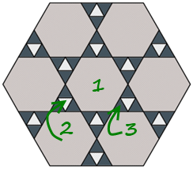  I randomly picked to start with the very center piece, but any of those pieces will work. Based on our chart, there are a few things we can answer right now. We see the shape has 6 sides. This makes it a Hexagon. We also can see that none of the edges crosses over another edge, thus we have a simple shape. Using our slide n’ measure on the figure on the handout, we find that the shape has a side length of about an inch (or 2.5 cm, depending on which scale you would like to use). It should be noted that each side has this same length. Now we can take our slide n’ measure and check each angle. We should be getting 120° for each angle inside of our hexagon. While we are on degrees, this would be a good time to figure out the amount of degrees in an exterior angle.  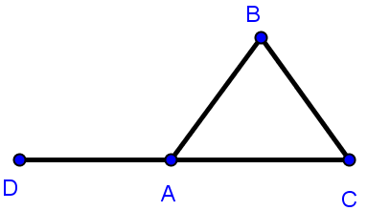  In the image above, would be an interior angle while would be its exterior angle. This is because is formed by extending outward. A special property of exterior angles is that the sum of the exterior angles of a shape add to 360° (the reasoning as well as a graphic for this can be found here: http://www.mathsisfun.com/geometry/exterior-angles-polygons.html). Since we have 6 sides to our shape we will have 6 exterior angles. In addition, we know that since each interior angle is 120°, each exterior angle must be 60° since they will all be supplementary to the interior angles. Thus, we have . If we take measurements for any of the other hexagons, we will find that the angles are all the same. Based on our definitions for Similar shapes and Congruent shapes, we have a candidate here. Now we need to check the sides. Doing so will tell us that the side lengths are the same for all the hexagons. In this case, we have similar hexagons, where the ratio of proportion for the sides is 1:1. That also means we have congruent hexagons. As such, it will not matter how George keeps track of his hexagon tiles. He does not need to indicate which one goes where in the pattern as any hexagon he cuts that is congruent with the first will work.  Let’s do the blue shape next. Following the same initial steps, we have a 3-sided figure or triangle. We can measure the angles to find each is 60° and measure the side length to see that each is 1/2 of an inch (which makes sense as two blue triangles make up the side of the hexagon which was 1 inch). Since all the sides/angles are the same, we have a regular triangle, and nothing overlaps so it is simple. And, once again, all of our white triangles are congruent to one another.  Finally, we are left with the white triangle. Like the previous shape, we know it’s a triangle by its three sides. Since not all triangles are necessarily equilateral/equiangular, we need to measure this one to check. We can use our protractor, or we can look at our pattern.  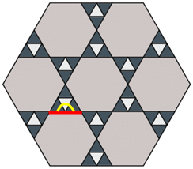  Here, we can see that the white triangle and the blue triangles have angles that lie on the same line. Since these three angles form a line, they add to 180°. This means the indicated angle of the white triangle must be 60° since the two blue angles will sum to 120°. By this same argument, we could find that the other 1 angles of our triangle are 60°. Then, by measuring, we can find our side lengths are all 1/2 inch. This tells us that the white triangles are congruent to the blue triangles. So our information in those two rows should be identical.  (We do) Have the students work with you to do the same thing with the bathroom floor tiles.  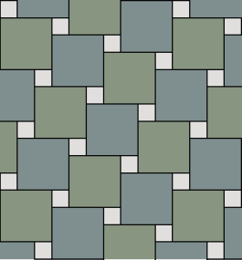  (You do) Have the students do the final two examples. They can do this in class, or save one to turn in. The hope is that by the last one, they can see that the exterior angles of a regular polygon can be found by:  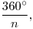  and the interior angles of a regular polygon can be found by:  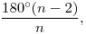  where n is the number of sides of the polygon.  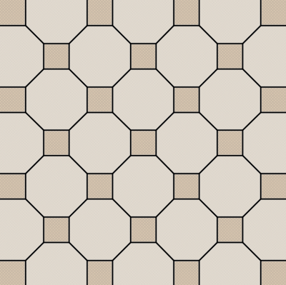  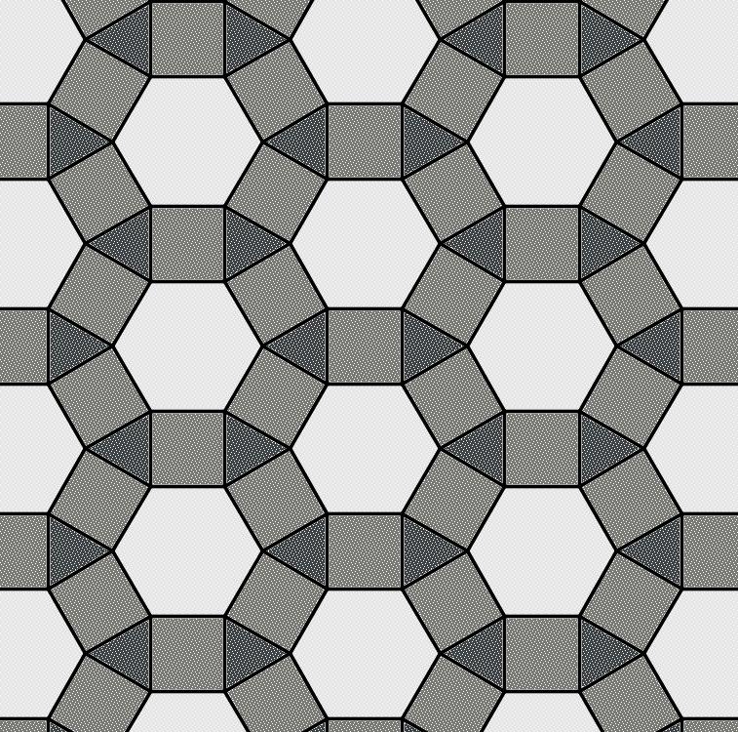  Before moving on, there are some other points we should discuss. It should be noted that the triangles have 180°. In fact, all triangles, even if they aren’t equilateral/equiangular, will have 180° in their interior angles. From there, we can find the interior angle sum of all other polygons. We do this by finding how many triangles will fit into a particular shape. Take a hexagon for example:  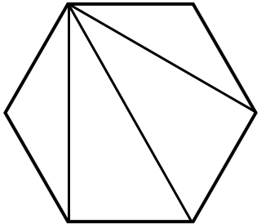  Since we can make four triangles inside the hexagon (they all need to go from the same vertex or corner), then we have in the interior of that shape. This is how we derive the formula from above:  since we can always make 2 less triangles than our total number of sides.  Part 3: Beyond shapes, another area in which angles are important is with parallel lines. If you take two parallel lines and intersect them with another line, very interesting properties arise with the angles formed. But, let’s approach this from the opposite end. Let’s say Maureen and George have taken a break after finishing their kitchen and bathroom. Pleased with the results, they decide to put hardwood flooring into their living room. Once again, wanting to save money, George needs to cut some of the boards himself so that they will fit once he gets to the end of the room. For appearances, they want to make sure the boards stay parallel to both walls. In order to ensure this, George wants to check to make sure his walls are parallel. To do this, he wants to utilize some angles and parallel lines properties.  When it comes to parallel lines, the following diagram is very common:  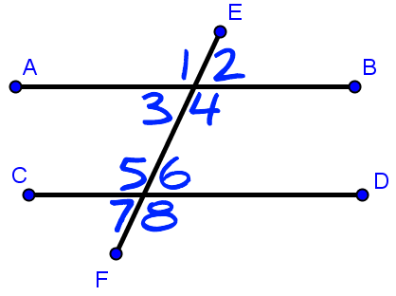  In the diagram above, segment AB is part of a line that is parallel to segment CD. In addition, segment EF is a random transversal that intersects our two parallel lines. So we have two parallel lines cut by a transversal. In this situation, we know that alternate interior angles are congruent (, ), alternate exterior angles are congruent (, ), corresponding angles are congruent (, , , ), and same-side interior angles are supplementary (, ). Fortunately, we can work backwards here as well. If I have two lines cut by a transversal and I want to know if segment AB is parallel to segment CD, then I just need to check to see if I have congruent alternate interior angles, or congruent alternate exterior angles, etc.  (I do) Make sure everyone has the Parallel Flooring handout. To start out, George needs to check to see if his walls are parallel. He makes a dotted chalk line between the two walls so that he can measure an angle between the walls and this newly formed transversal. He takes some measurements that he writes down as in the diagram on the handout. Are his walls parallel?  We see that George took two angle measurements. The red box tells us that we have a right angle (90°) in the bottom left corner of the room. In addition, we see that his measurements denote a 36° angle and a 54° angle. Since we want to find out if we have parallel lines, we need to see if we have either supplementary same-side interior angles, or if we have congruent angles of one of our other three types (alternate interior, alternate exterior, or corresponding). We don’t have the set-up for corresponding or alternate exterior angles since George can only measure interior angles, but either of the other two ways will work. To get used to the congruent angles, let’s use alternate interior. We do not currently have a pair of alternate interior angles labeled. However, since we know we have a 90° angle in the bottom left, we know that the missing portion of the angle must be complementary to the 36° angle. Thus, that missing portion is 54°. Now, we do have a pair of alternate interior angles, and since they are the same degree measure, they are congruent. This tells us those two walls (top and bottom) are parallel. We can check this by using same-side interior angles. It may look like we currently have a pair, with the two given angles. However, in order for our angles to be useful, they must be measured from the parallel line. Our 36° angle does not have the parallel line as one of its sides, so it doesn’t count. But, we can extend our bottom wall out to get the following diagram:  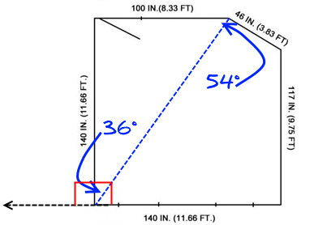  Since we knew that the left-side wall created a 90° angle inside the room, and we know if we extend out that bottom line we should have a straight angle, then the new angle formed must also be 90°. (We also know that if two lines intersect and form one right angle, they are perpendicular and actually form 4 right angles.) Now we have an angle that extends from the bottom wall all the way to the dotted line made by George. This angle will be the 36° angle he measured, plus the right angle we just formed: 36° + 90° = 126°. Now we can check same-side interior angles. We have 54° + 126° = 180°, so our same-side interior angles are supplementary, making our lines parallel.  (We do) Have the class do the first flooring cut problem with you. George needs to see if his first cut is parallel.  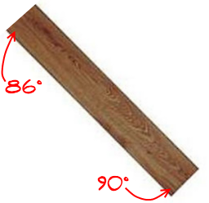  (Note: The 90° angle is probably the precut angle, though that won’t really affect our calculations.) We once again only have interior angles, though we can use the trick of extending lines around the right angle to give ourselves more angles. With the given picture, it would make sense to use same-side interior angles and see that we do not have supplementary angles, thus do not have a parallel cut.  (You do) Have the students do the final problem on the handout.  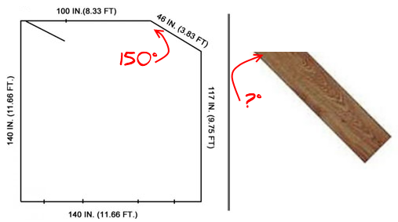  In this scenario, George was able to measure the angle between the angled wall and the wall he first dealt with. That large angle is 150°. However, that will obviously not be the angle of a board that goes there. Instead, we must think about the angle between the wall and the already installed flooring. In that case, we have:  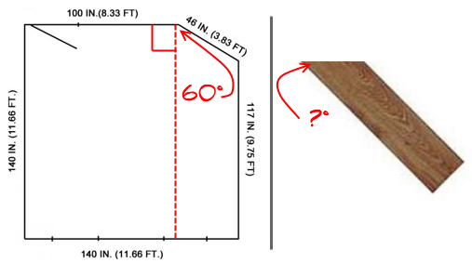  The previous boards were placed parallel to the top and bottom walls. We were first told that the bottom left hand corner of the room is a right angle. That’s going to tell us that if we box off the room, as above, we will have 4 right angles. (This can be shown using same-side interior angles, and alternate interior angles.) This tells us that drawing in the edge of the already installed flooring will create the right angle above. Then, we have that 150° - 90° = 60°, as shown above. Since we can consider laying the board alongside the dotted line in the left picture, we basically want to check to see if we have parallel lines. We want the unknown angle to be congruent to that 60° angle, so the marked angle on the board needs to be 60° when George cuts it for it to lay flush against the wall.  As a final part of the lesson, especially if there is time in class, have the students check different lines in the room to see if they are parallel. |  |  |  |  | RESOURCES  SmartPal kit (SmartPal sleeves, wipe off cloths, dry erase markers) – inserting a blank sheet of paper into the sleeves will give students a reusable sheet of paper that they can quickly try answers out on and erase without using up a pencil eraser. It’s quicker as well.  Attribute blocks  Slide N’ Measure compass  Tessellating Tiles Exploration—Handout  Parallel Flooring — Handout  Problem Solving Steps—Handout  http://www.core-learning.com/downloads/resources/math/geo_apdx2.pdf  http://www.geogebra.org
  Shape | # of sides | Regular or Irregular? | Simple or Complex? | Degrees in an interior angle | Degrees in an exterior angle | Length of a side
  Shower Floor
  Hexagon | 6 | Regular | Simple | 120 | 60 | 1 inch
  Blue Triangle | 3 | Regular | Simple | 60 | 120 | 1/2 inch
  White Triangle | 3 | Regular | Simple | 60 | 120 | 1/2 inch
  Shape | # of sides |  | Regular or Irregular? |  | Simple or Complex? |  | Degrees in an interior angle | Degrees in an exterior angle | Length of a side
  Bathroom Floor
  Blue Square |  | 4 |  | Regular |  | Simple | 90 | 90 | 1 inch
  Green Square |  | 4 |  | Regular |  | Simple | 90 | 90 | 1 inch
  Small Square |  | 4 |  | Regular |  | Simple | 90 | 90 | 1/3 inch
  Shape | # of sides | Regular or Irregular? | Simple or Complex? | Degrees in an interior angle | Degrees in an exterior angle | Length of a side
  Kitchen Sink Backdrop
  Square | 4 | Regular | Simple | 90 | 90 | 1/2 inch
  Octagon | 8 | Regular | Simple | 135 | 45 | 1/2 inch
  Shape | # of sides | Regular or Irregular? | Simple or Complex? | Degrees in an interior angle |  | Degrees in an exterior angle |  | Length of a side
  Kitchen Floor
  Hexagon | 6 | Regular | Simple |  | 120 |  | 60 | 1/2 inch
  Square | 4 | Regular | Simple |  | 90 |  | 90 | 1/2 inch
  Triangle | 3 | Regular | Simple |  | 60 |  | 120 | 1/2 inch
 | DIFFERENTIATION
Reflection | TEACHER REFLECTION/LESSON EVALUATION
Reflection | Additional Information  NEXT STEPS  The Pythagorean theorem would be a great follow-up to this lesson. It would allow students to further explore right triangles, which are used heavily in geometry courses. Another option would be to start working with the coordinate plane and graphing lines with their equations. This would allow them to further explore properties of parallel and perpendicular lines as well as plot shapes.  PURPOSEFUL/TRANSPARENT  Students want to see how geometric properties can be incorporated in an everyday setting. Instructors will use examples from around the home to help accomplish this task.  CONTEXTUAL  Geometric properties are inherently real-world. The properties of angles and shapes are very hands on and can be seen in real-world representations of those objects. Angle theorems and properties are used by those in architecture and construction to make sure their plans/blueprints are feasible and to make precise cuts when building. Right angles and triangles, especially the Pythagorean theorem, are useful here.  BUILDING EXPERTISE  Much of geometry is built upon definitions and theorems. Having a solid foundation here will allow students to build upon that knowledge using formulas for area, perimeter, and volume, as well as further explore properties and theorems with shapes and angles.
NOTE: The content in the Additional Information box exceeds what is required for the OBR Approved Lesson Plan Template. This information was provided during the initial development of the lesson, prior to the creation of the OBR Approved Lesson Plan Template. Feel free to remove from or add to the Additional Information box to suit your lesson planning needs.
Parallel Flooring

George and Maureen Johnson are ready to put hardwood flooring into their living room and want to make sure that the flooring is put down so that all pieces are parallel, not only to each other, but to the walls as well.

First, George must make sure his walls are parallel, so that if he is making the pieces parallel to one wall, they will also be parallel to the other wall. He takes the following measurements of his living room:
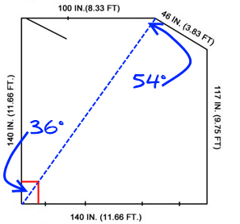
Are the two walls at the top and bottom of the picture parallel?
As George gets to the end of his first row of flooring, he needs to cut his first board. He feels a little shaky with the saw and isn’t sure he cut it perfectly parallel. He decides that if he can check to see if his walls are parallel, he can check to see if the board is as well. He takes the following angle measurements:
Is his cut parallel?

The Johnson’s living room has an angled wall. Knowing it will give him issues, George decides to do this part last. When he gets to it, he cannot line a board up to mark the angle at which to cut. How can he use what he knows about parallel lines to help him? He already knows the following:
What angle will he need to cut at in order to make sure the board fits flush against the wall?

Tessellating Tiles Exploration

George and Maureen Johnson decide to do some remodeling of their home. They found some tile patterns on the internet that they liked. To save money, George decides that he will buy tiling of the colors they want in bulk and cut out the shapes they need. He will then try to recreate the pattern.

You may find it useful to recreate the following table to aid you in answering each question.

Shape | # of sides | Regular or Irregular? | Simple or Complex? | Degrees in an interior angle | Degrees in an exterior angle | Length of a side
Shower Floor
Bathroom Floor
Kitchen Sink Backdrop
Kitchen Floor

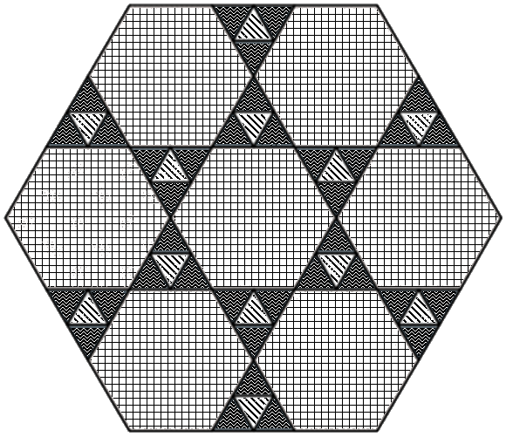
The first room they want to work on is the bathroom. They want to upgrade the floor of their shower to have the following pattern:

What shortcuts can George take when cutting out the shapes?

Can he interchange their positions?

Can they be rotated?

Are the same?

Similar?

What can be said about the shapes, angles, and sides in the pattern?

The next area that George and his wife want to retile is the bathroom itself. They decide to go with the following pattern:
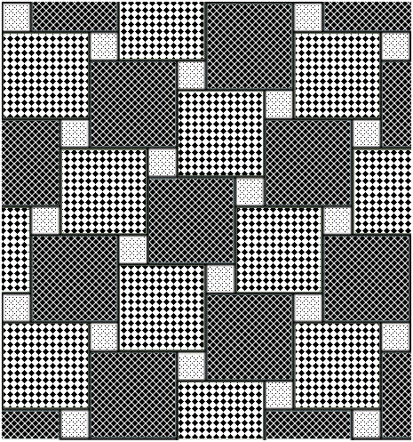
Again, what sort of shortcuts can George take?

Does he need to keep the cut pieces facing a certain direction?

Does it matter if he just throws them all onto a pile?

What does he know about the shapes?

How can they be compared?

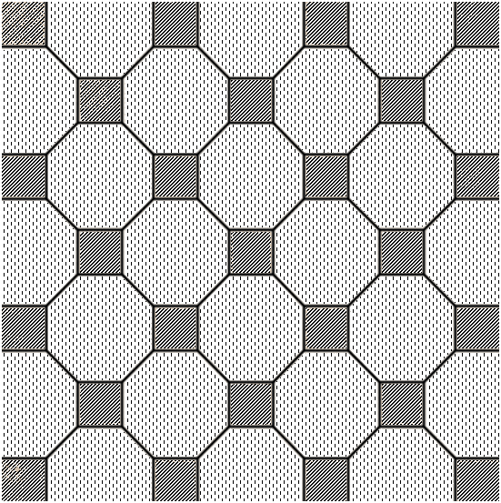
After finishing up in the bathroom, Maureen decides they should work on the kitchen. They choose the following pattern to put as a backdrop behind their sink:

As Maureen cuts the tiles for this pattern, what do you notice about the shapes?

The angles?

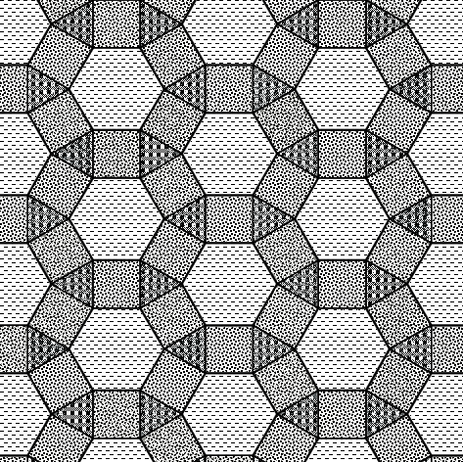
The final area they need tile for is the kitchen floor. Maureen brings George back in to help her recreate this pattern:

In this final pattern, can you find the interior angles of each shape without measuring?

How?

Do you notice a pattern to the degrees in an interior angle of certain shapes?

Regular or irregular?

Complex or simple?

